

Name: ______________________ Seat # ____
Homework 6 - On Lecture 7 - Exceptions
(100 points) Hours:

The homework is to be turned in as a PAPER AND PENCIL i.e., HANDWRITTEN ANSWER ONLY!(with your terminal #!) in the first ten minutes of the due date class.

Also an implementation in NetBeans Java is ALSO required, thus you are to submit the ZIPPED project to BB and download it in 232 PGH the first 10 minutes of class. Hardcopy with screenshots of the running program and the SOURCE CODE are also needed.
TURNING IN THE HOMEWORK INSTRUCTIONS will be PENALTY OF -10 points.
I UNDERSTAND THAT TURNING ANOTHER’s WORK IN is CHEATING.
I UNDERSTAND THAT ANY KIND OF DISSEMINATION of this WORK is CHEATING.

I CERTIFY THAT THE HOMEWORKs SOLUTIONs ARE MY OWN WORK!
V
X
?
SIGNATURE:

HOMEWORK CHECKLIST (YOU MUST GRADE YOURSELF!):
TA check, is
Homework6.zip
in BB?
- DID TURN IN HOMEWORK INSTRUCTIONS?* -10 points

- 1.? 64 points
- 2.? 36 points

- Homework6.2 JAVA.zip NOT submitted to BB? * -36 points
- Homework6.2 JAVA.zip NOT running in class? * -36 points

* If NOT, do not enter anything in the box!
TA grade or check

PLEASE ENTER YOUR GRADE IN THIS BOX:

By Hand?

Screenshot?

I understand that if the .zip file is NOT in BB and I did not check the BOX, I will get a ZERO for the Homework!

1. (64 pts)

a. (8 pts) What output is produced by the following code?

int waitTime = 46;

try
{
System. out. println(" Try block entered.");
if ( waitTime > 30)
throw new Exception(" Over 30.");
else if ( waitTime < 30)
throw new Exception(" Under 30.");
else
System. out. println(" No exception.");
System. out. println(" Leaving try block.");
}

catch( Exception thrownObject)
{
System. out. println( thrownObject. getMessage());
}

System. out. println(" After catch block");
Program in Netbeans AS HOMEWORK6.a build and run and show the output! (hardcopy of the code and screenshot of the output + submit zipped project to BB!)

ANSWER:

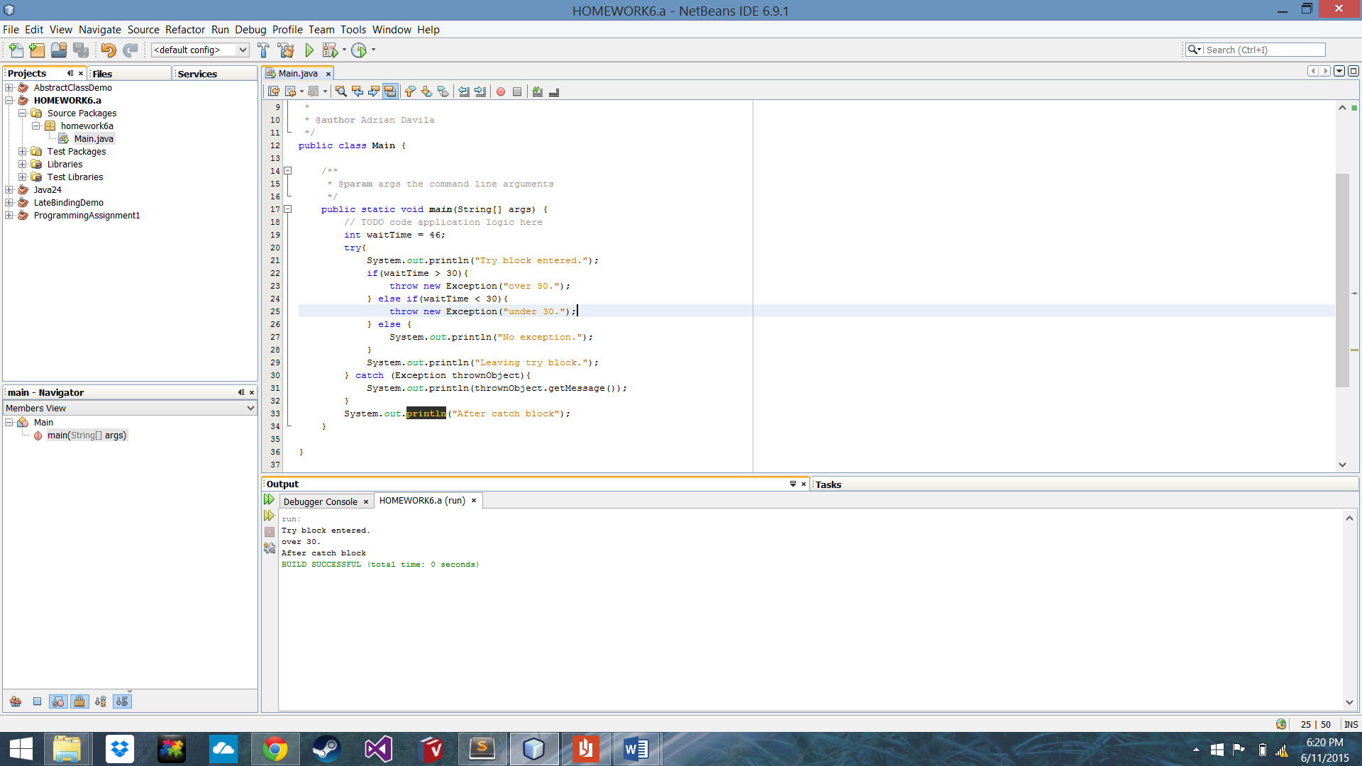

b. (8 pts) Suppose that in exercise a. above, the line

int waitTime = 46;

is changed to

int waitTime = 12;

How would this affect the output?
Program in Netbeans AS HOMEWORK6.b build and run and show the output! (hardcopy of the code and screenshot of the output + submit zipped project to BB!)

ANSWER:

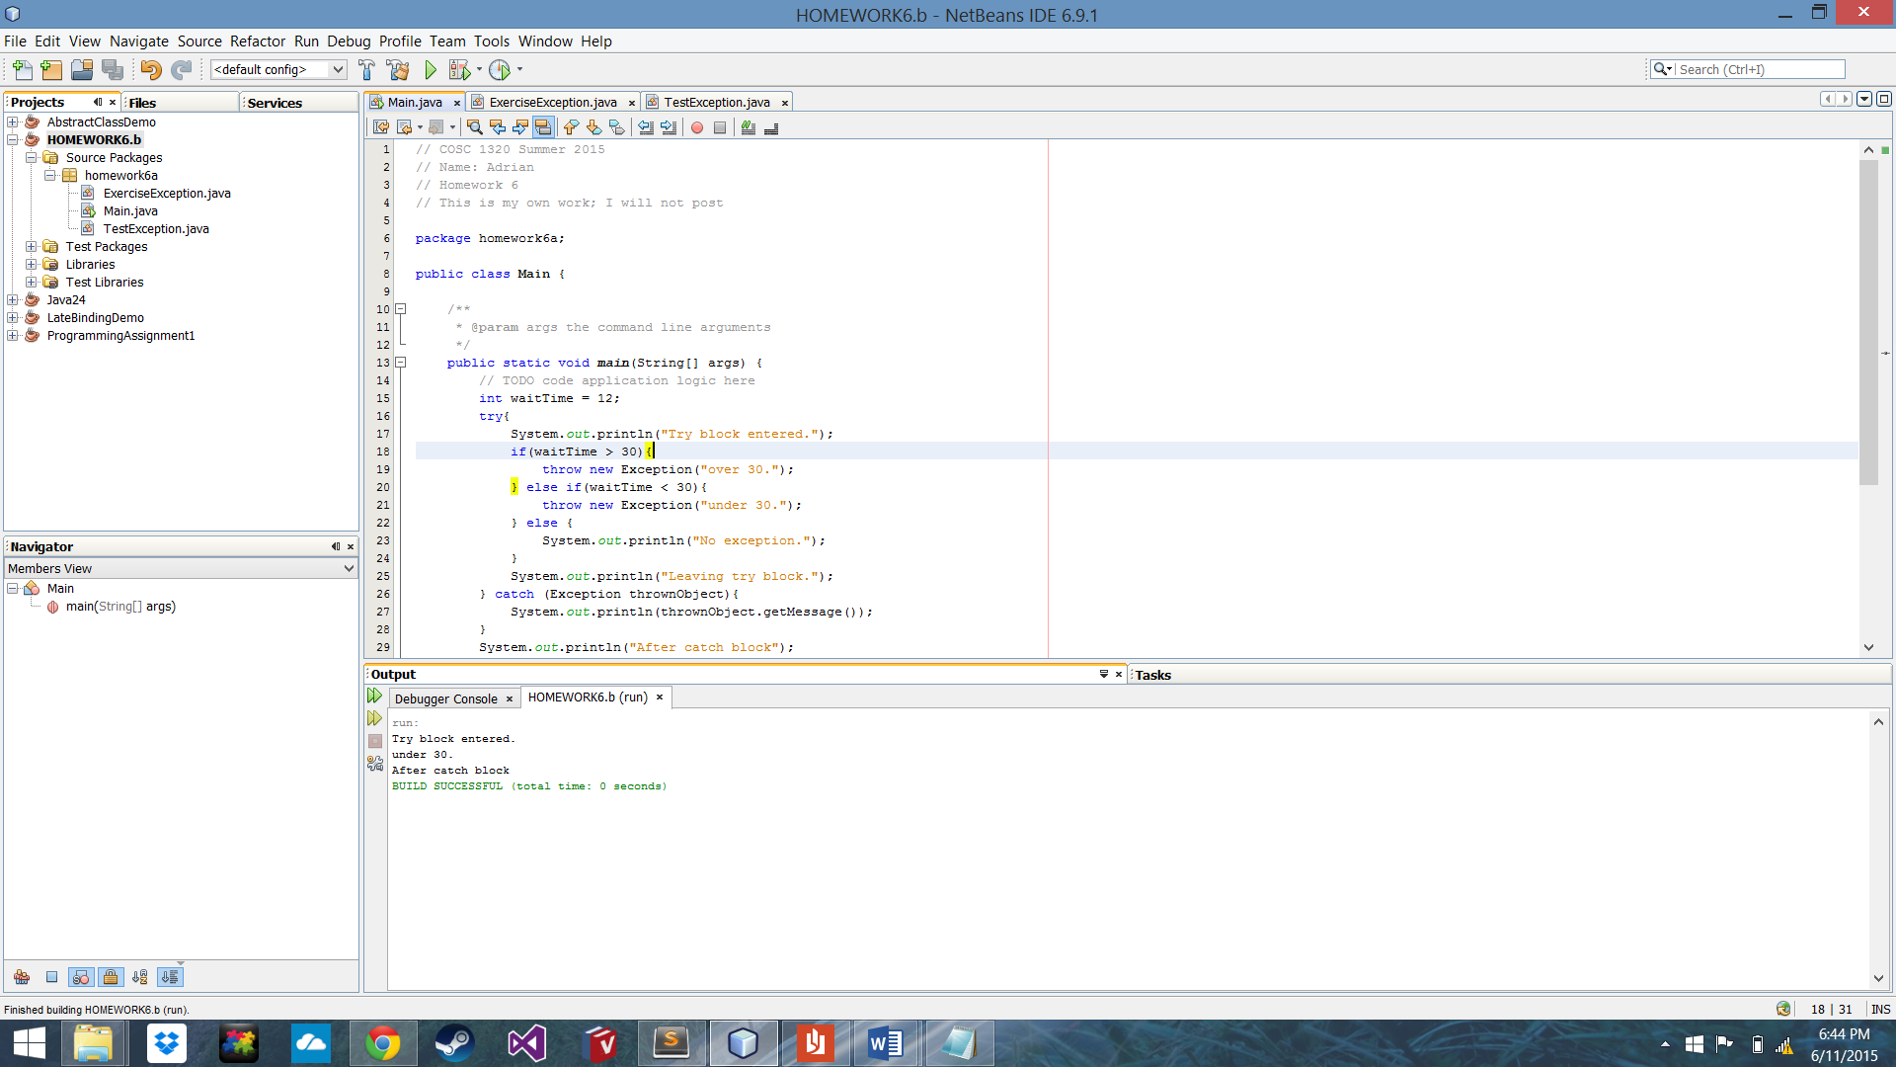

c. (8 pts) Suppose the exception class ExerciseException is defined as follows:

public class ExerciseException extends Exception
{
public ExerciseException()
{
super(" Exercise Exception thrown!");
System. out. println(" Exception thrown.");
}

public ExerciseException( String message)
{
super( message);
System. out. println( " ExerciseException invoked with an argument.");
}
}

What output would be produced by the following code ( which is just an exercise and not likely to occur in a program)?

ExerciseException e = new ExerciseException(" Do Be Do");
System. out. println( e. getMessage());

The class ExerciseException is on the CD that comes with this text.
Program in Netbeans AS HOMEWORK6.c build and run and show the output! (hardcopy of the code and screenshot of the output + submit zipped project to BB!)

ANSWER:

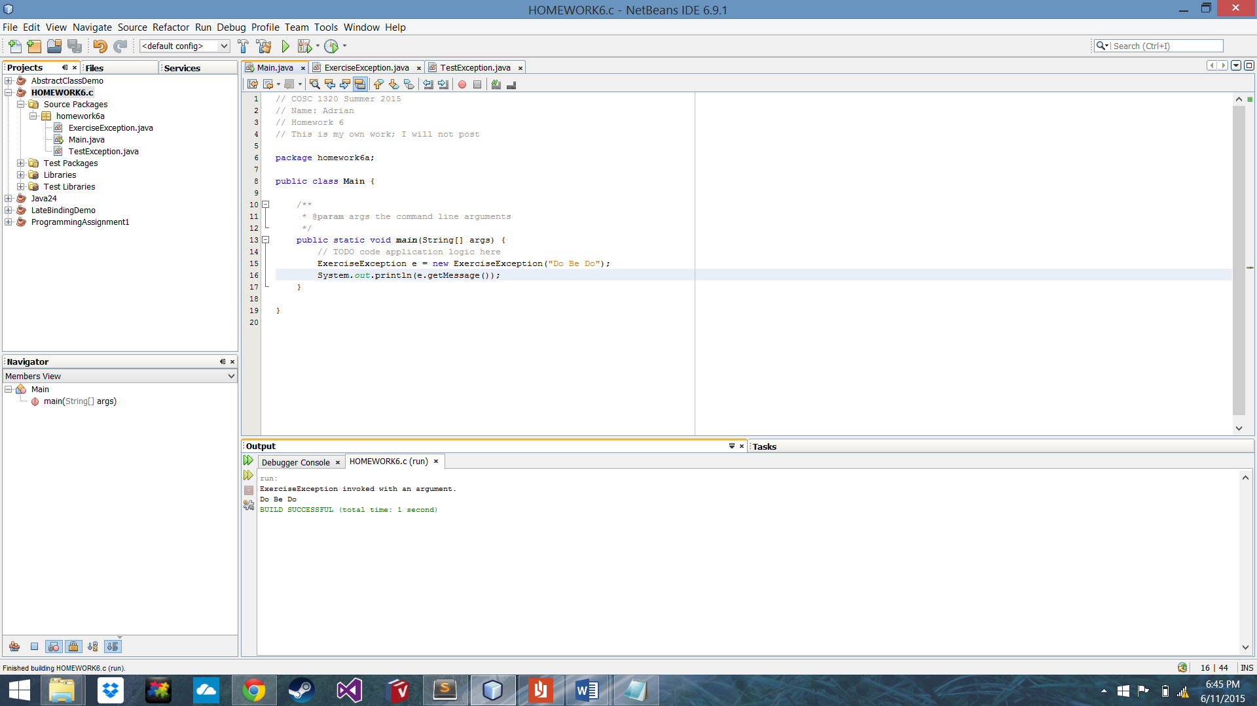

d. (8 pts) Suppose the exception class TestException is defined as follows:

public class TestException extends Exception
{
public TestException()
{
super(" Test Exception thrown!");
System. out. println( " Test exception thrown!!");
}

public TestException( String message)
{
super( message);
System. out. println( " Test exception thrown with an argument!");
}

public void testMethod()
{
System. out. println(" Message is " + getMessage());
}
}

What output would be produced by the following code ( which is just an exercise and not likely to occur in a program)?

TestException exceptionObject = new TestException();
System. out. println( exceptionObject. getMessage());
exceptionObject. testMethod();

The class TestException is on the CD that comes with this text.
Program in Netbeans AS HOMEWORK6.d build and run and show the output! (hardcopy of the code and screenshot of the output + submit zipped project to BB!)

ANSWER:

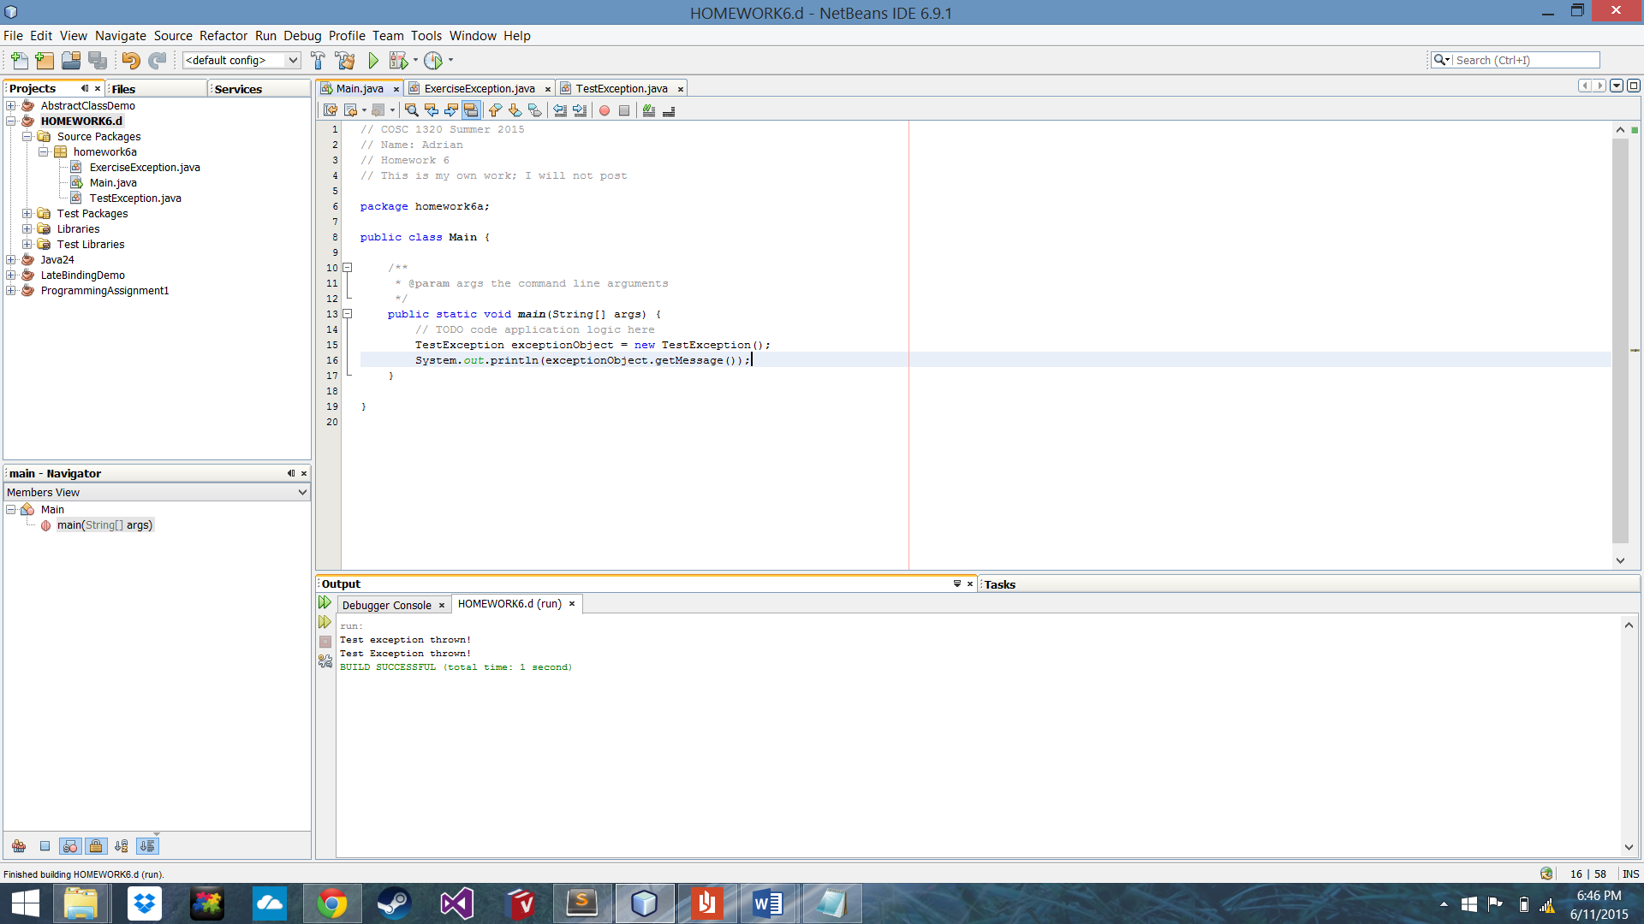

e. (8 pts) Suppose the exception class MyException is defined as follows:

public class MyException extends Exception
{
public MyException()
{
super(" My Exception thrown!");
}

public MyException( String message)
{
super(" MyException: " + message);
}
}

What output would be produced by the following code ( which is just an exercise and not likely to occur in a program)?

int number;
try
{
System. out. println(" try block entered:");
number = 42;
if ( number > 0)
throw new MyException(" Hi Mom!");
System. out. println(" Leaving try block.");
}

catch( MyException exceptionObject)
{
System. out. println( exceptionObject. getMessage());
}

System. out. println(" End of example.");
The class MyException is on the CD that comes with this text.
Program in Netbeans AS HOMEWORK6.e build and run and show the output! (hardcopy of the code and screenshot of the output + submit zipped project to BB!)

ANSWER:

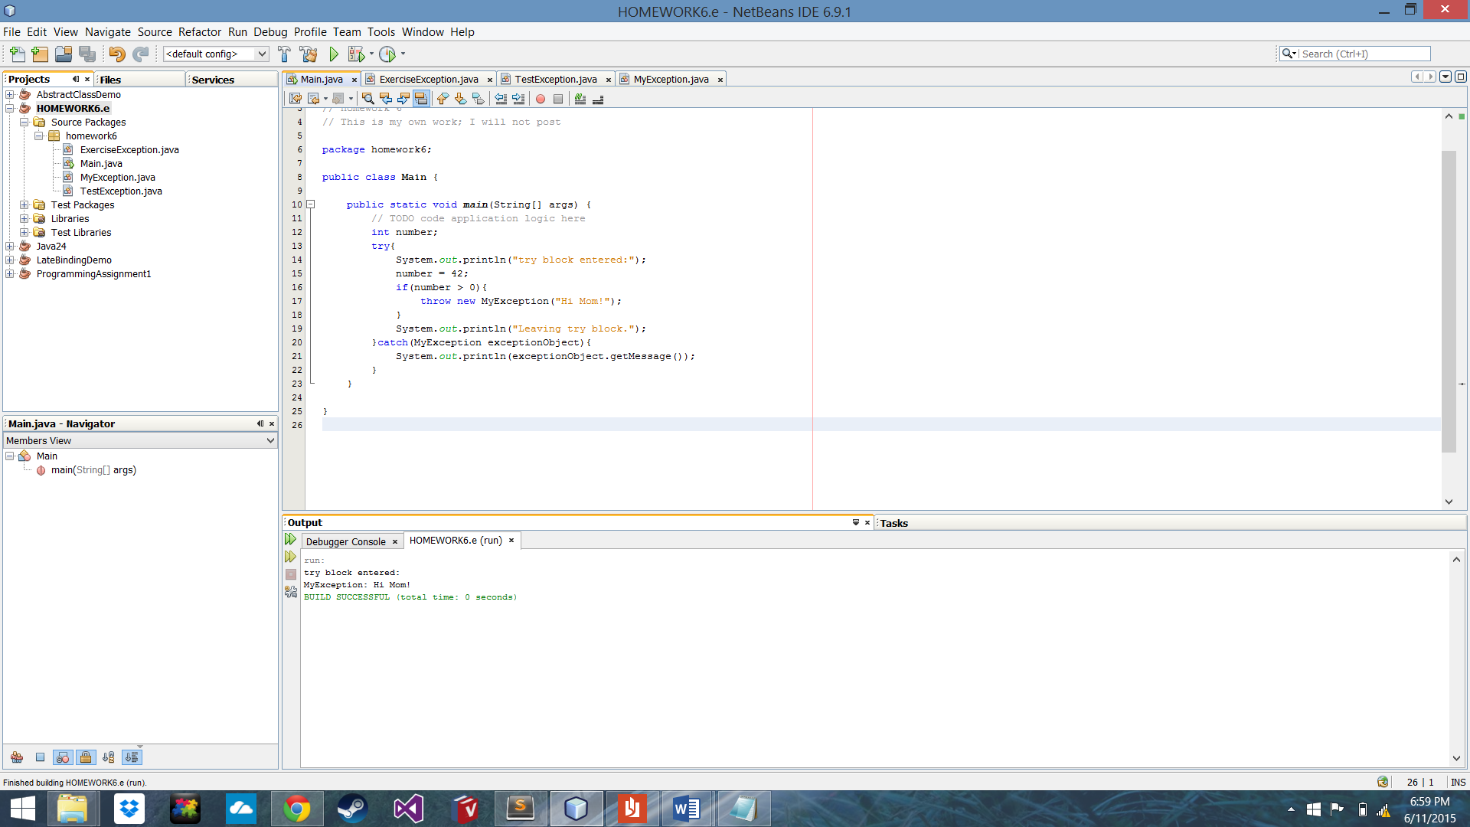

f. (8 pts) What output will be produced by the following code? ( The definition of the class NegativeNumberException is given in Display 9.8.)

int n;
try
{
n = 42;
if ( n > 0)
throw new Exception();
else if ( n < 0)
throw new NegativeNumberException();
else System. out. println(" Bingo!");
}
catch( NegativeNumberException e)
{
System. out. println(" First catch."); } catch( Exception e) { System. out. println(" Second catch.");
}
System. out. println(" End of exercise.");
Program in Netbeans AS HOMEWORK6.f build and run and show the output! (hardcopy of the code and screenshot of the output + submit zipped project to BB!)

ANSWER:

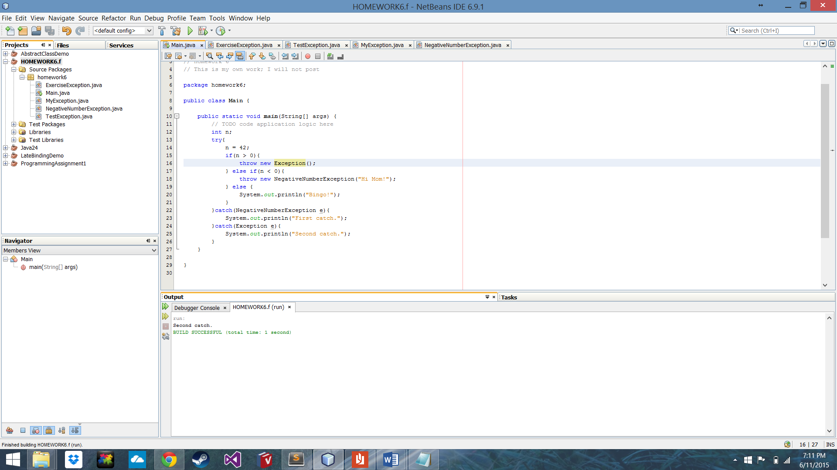

g. (8 pts) What is the output produced by the following program?

public class Exercise
{
public static void main( String[] args)
{

try
{
System. out. println(" Trying");
sampleMethod( 98.6);
System. out. println(" Trying after call.");
}

catch( Exception e)
{
System. out. println(" Catching.");
}

System. out. println(" End program.");
}

public static void sampleMethod( double test) throws Exception
{
System. out. println(" Starting sampleMethod.");
if ( test < 100)
throw new Exception();
}
}

The class Exercise is on the CD that comes with this text.
Program in Netbeans AS HOMEWORK6.g build and run and show the output! (hardcopy of the code and screenshot of the output + submit zipped project to BB!)

ANSWER:

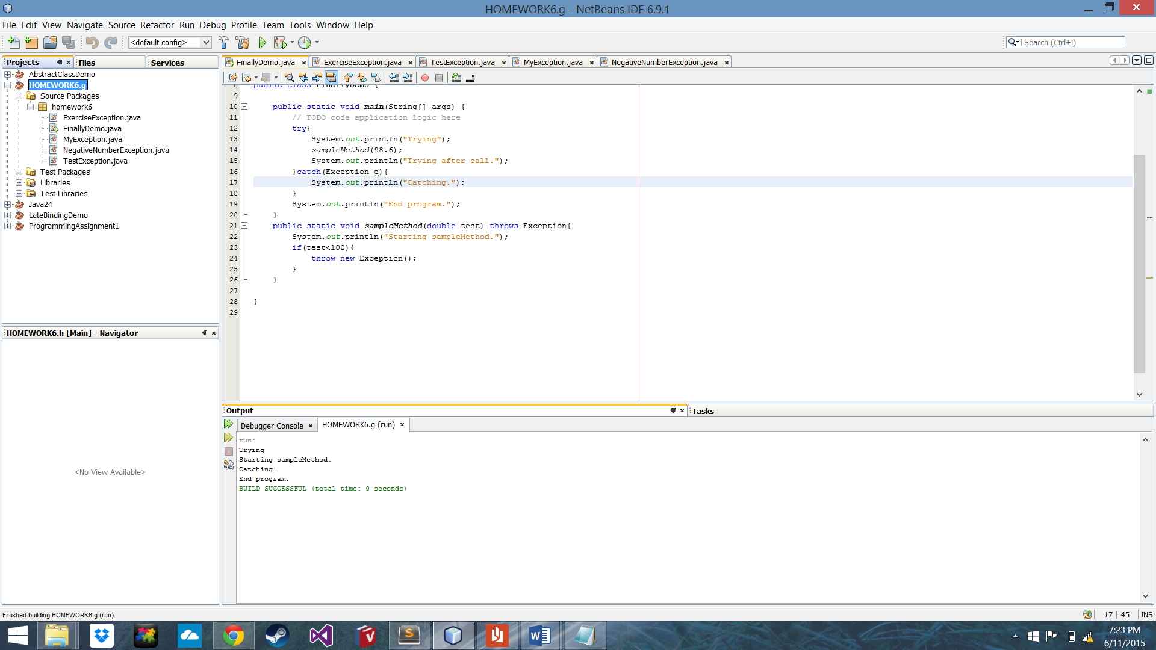

h. (8 pts) What is the output produced by the following program? What would the out-put be if the argument to exerciseMethod were - 42 instead of 42? ( The class NegativeNumberException is defined in Display 9.8, but you need not review that definition to do this exercise.)

public class FinallyDemo
{
public static void main( String[] args)
{
try
{
exerciseMethod( 42);
}

catch( Exception e)
{
System. out. println(" Caught in main.");
}
}

public static void exerciseMethod( int n) throws Exception
{
try
{
if ( n > 0)
throw new Exception();
else if ( n < 0)
throw new NegativeNumberException();
else
System. out. println(" No Exception.");
System. out. println(" Still in sampleMethod.");
}
catch( NegativeNumberException e)
{
System. out. println(" Caught in sampleMethod.");
}
finally
{
System. out. println(" In finally block.");
}
System. out. println(" After finally block.");
}
}

The class FinallyDemo is on the CD that comes with this text. extra code
Program in Netbeans AS HOMEWORK6.h build and run and show the output! (hardcopy of the code and screenshot of the output + submit zipped project to BB!)

ANSWER:

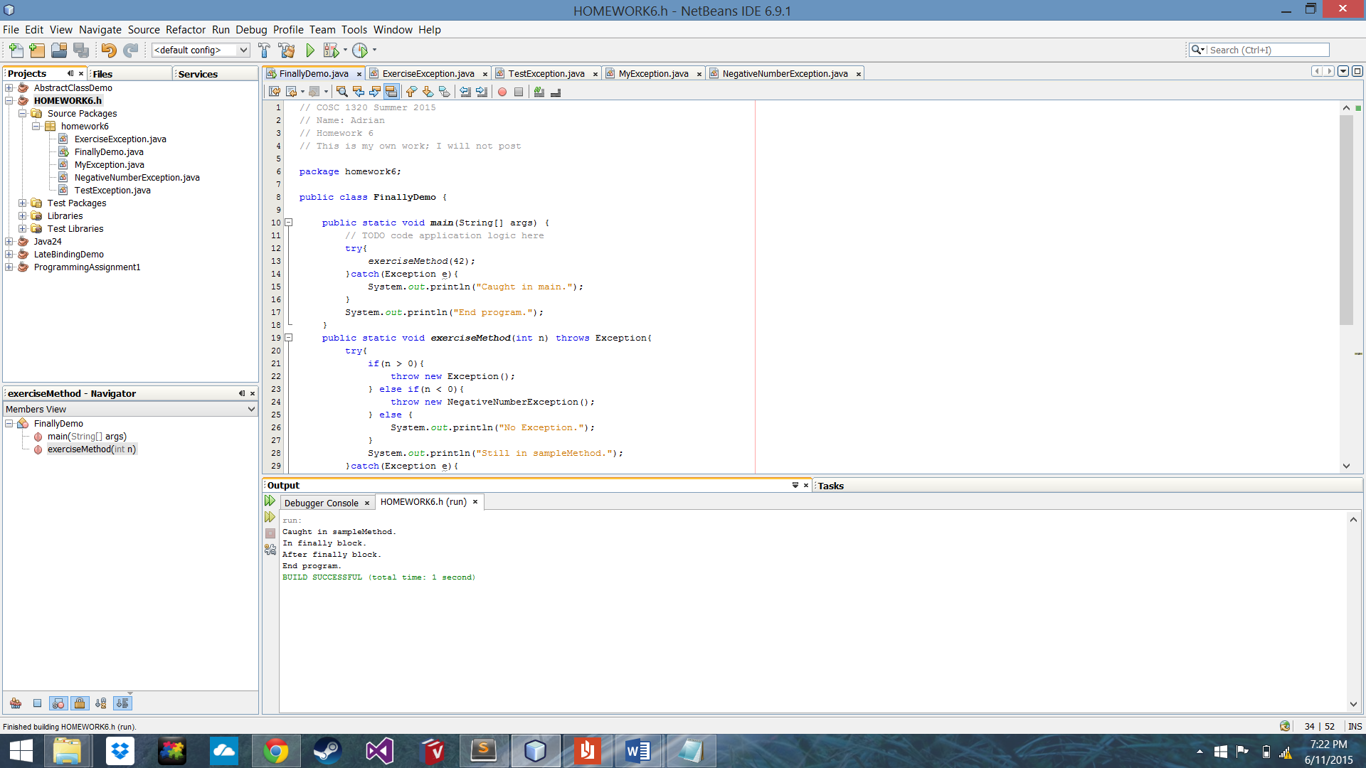

2. (36 pts)

A method that returns a special error code is usually better accomplished throwing an exception instead. The following Class maintains an account balance.

class Account
{
private double balance;

public Account()
{
balance = 0;
}

public Account( double initialDeposit)
{
balance = initialDeposit;
}

public double getBalance()
{
return balance;
} // returns new balance or - 1 if error

public double deposit( double amount)
{
if ( amount > 0)
balance += amount;
else
return - 1; // Code indicating error

return balance;
} // returns new balance or - 1 if invalid amount

public double withdraw( double amount)
{
if (( amount > balance) || ( amount < 0))
return - 1;
else balance -= amount;
return balance; }
}

Rewrite the Class so that it throws appropriate exceptions instead of returning - 1 as an error code. Write test code that attempts to withdraw and deposit invalid amounts and catches the exceptions that are thrown.

In Netbeans AS HOMEWORK6.2 build and run and show the output!
(hardcopy of the code and screenshot of the output + submit zipped project to BB!)

http://media.pearsoncmg.com/aw/aw_savitch_abjava_4/videos/video9_1/video.html

ANSWER:

